Computer assignment 3 – Synthesizing an Enclosure
- Choose an enclosure. This could be a stairwell, a basketball or racquetball court, a classroom, a hallway, an auditorium, etc. Take a picture or pictures of the enclosure to include in your report.
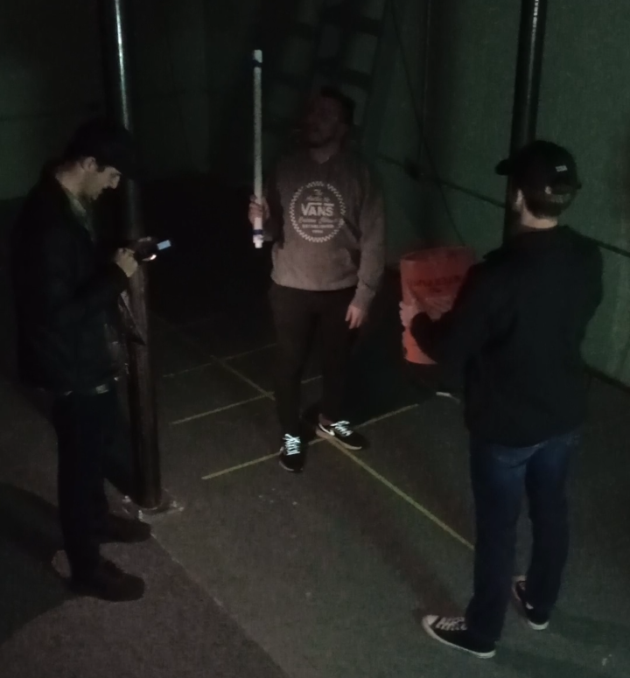
Figure 1: Basement below anechoic chamber where the impulse response was recorded.

- Select a means for creating an impulsive signal. This could be a cap gun, blocks of wood, a balloon pop, hand clap, etc. Take a picture or pictures of your impulse generator to include in your report. (Wear ear protection as needed.)
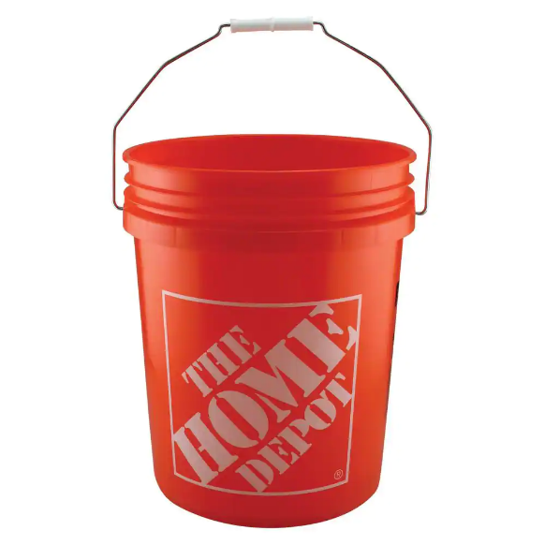
Figure 2: We used a bucket and a PVC pipe to whack it to produce the impulse response

- Select and test a means for measuring an audio signal. Software such as Audacity may be useful for this. Microphones built into laptop computers can be used.
- Choose a point within the enclosure for impulsive excitation and another point for impulse response measurement.
- Record the impulse response of the enclosure. Take a picture or pictures of your setup to include in your report.

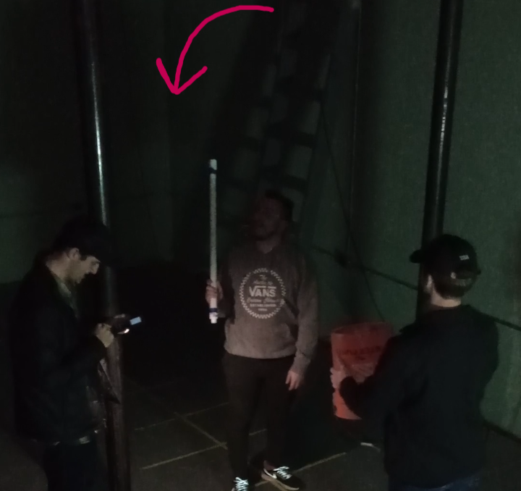
Figure 3: The phone used to record the audio was in the corner of the basement while the bucket was in the middle of the room

- Plot the impulse response and frequency response of the enclosure. For the impulse response plot, scale the y-axis so that the impulse response tail is visible. You may want to trim excess silence from the start and end of the impulse response. The x-axis should be scaled to show units of time in seconds (or milliseconds as needed). For the magnitude frequency response plot, include linear magnitude and logarithmic magnitude plots. The x-axis should be scaled to show units of frequency in Hertz. Include these plots in your report.

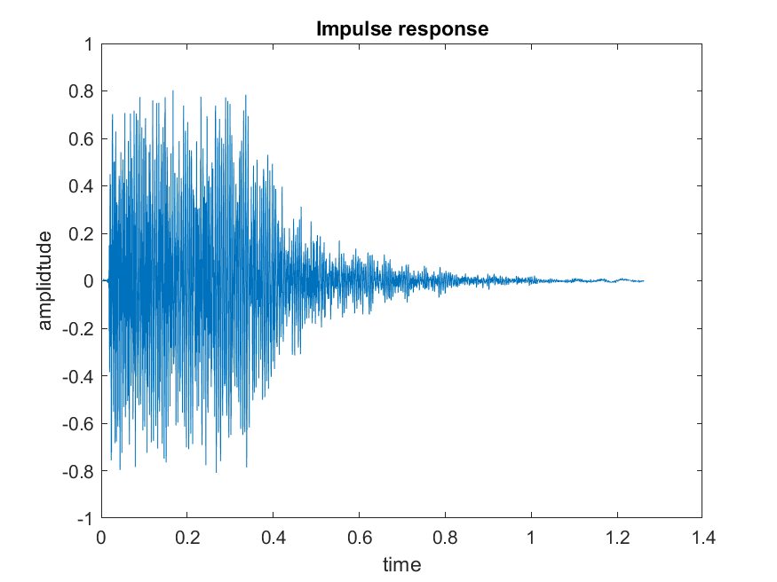
Figure 4: Impulse response plotted against time

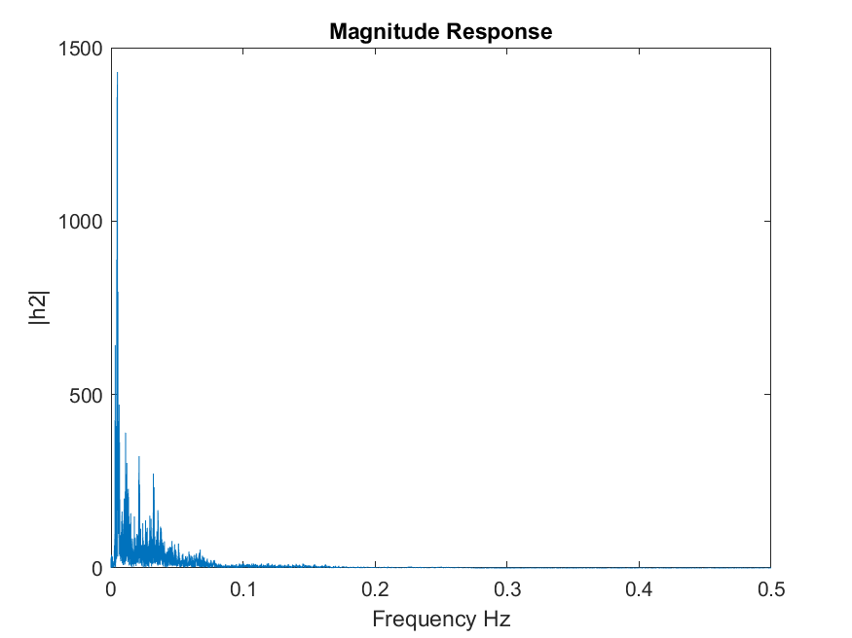
Figure 5: Magnitude of the frequency response.

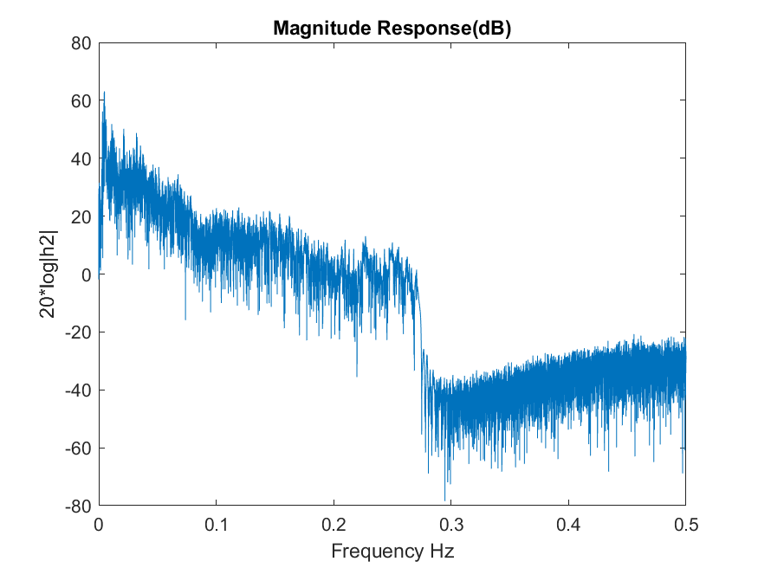
Figure 6: Magnitude response in decibels of the impulse response

- What is the approximate duration of the impulse response in seconds?

The impulse response was approximately 1.2seconds long.

- Save your impluse response in WAV format to include in your report.
- Go into the anechoic chamber and record 15 seconds or more of speech.
- Go into the anechoic chamber and record 15 seconds or more of a musical instrument.
- Plot these signals with the x-axis scaled to show time in seconds.

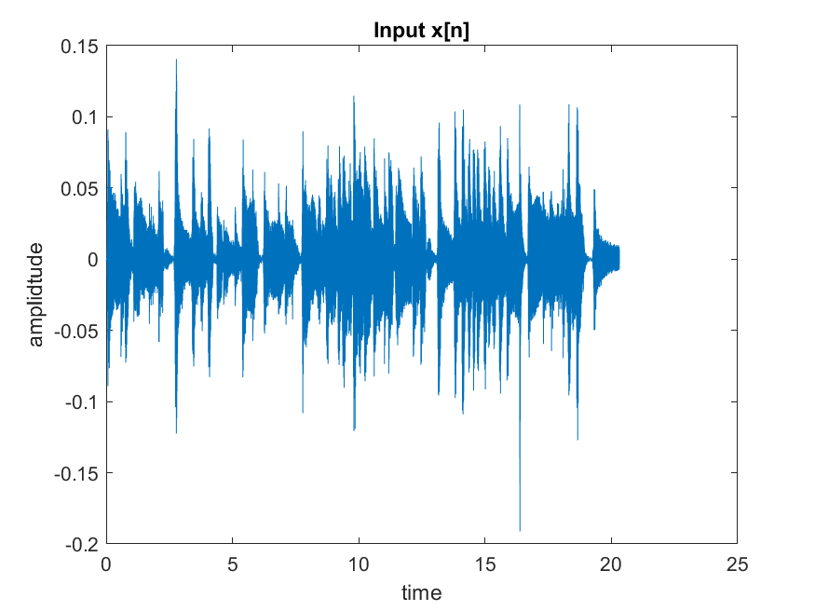
Figure 7: Guitar being played in the anechoic chamber

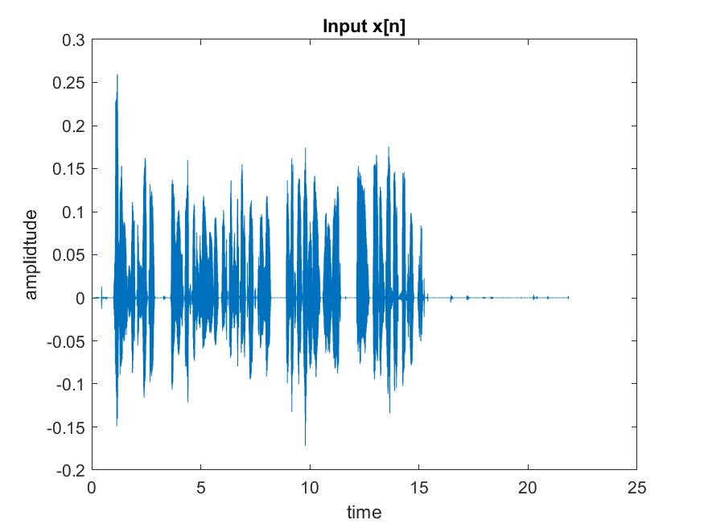
Figure 8: Speech recorded in the anechoic chamber.

- Make spectrogram plots of these signals to include in your report. Experiment with the FFT size, the window shape, and the overlap size until the time-frequency structure of the signals are visible.

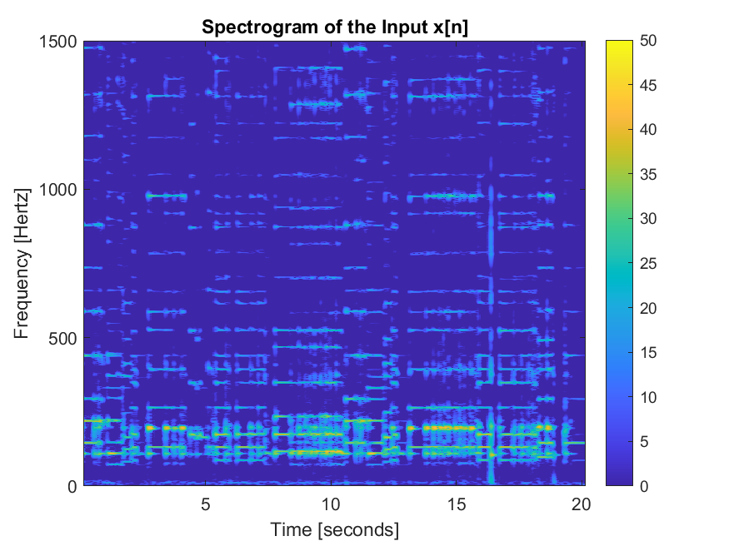
Figure 9: Spectrogram of the input guitar in the anechoic chamber

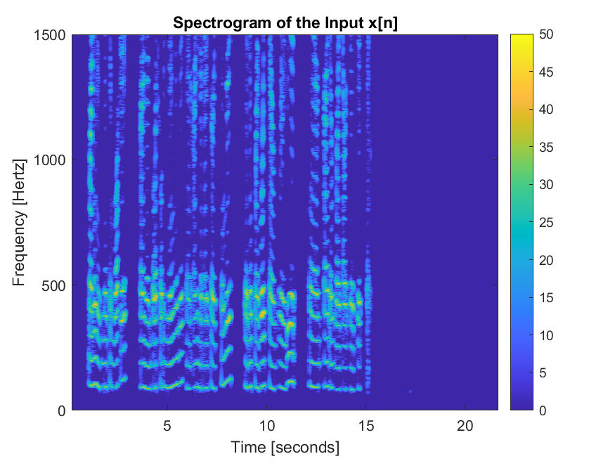
Figure 10: Spectrogram of the input speech in the anechoic chamber

- Save your dry signals in WAV format to include in your report.
- Note: The sample rate of these recordings should be the same as the sample rate used in the impulse response recording.
- Using the MATLAB programs from either CA1 or CA2, filter the dry signals through the measured impulse response. Listen to the filter output (wet signals) and comment on the filtering effect.

I decided to use the myconv function from CA1 to produce the output replicating the enclosure. However, after the convolution the output signal was outside the bounds of plus or minus 1 required for WAV files. So originally the audio sounded very bad and sounded clipped. Once reduced the amplitude, the sound sounded normal. The output audio from the convolution sounded as if the recordings were recorded in the basement rather than the anechoic chamber.

- Save the filtered signals in WAV format to include in your report.
- Turn in a report describing the procedure used in this lab to measure the impulse response, to record dry signals, and to synthesize wet signals. Comment on what you learned.

I learned that if you know the impulse response of different spaces, you can replicate what a dry signal would sound like in the space. I also learned that the convolution function that we made is not very efficient at computing the output. This I learned because it took about 8 minutes to convolve both inputs with the impulse response.

- What sample rate did you use? What effect does the sample rate have on the computational complexity of the filtering?

I ended up using 44100 samples per second. This increased the complexity by increasing the total amount of samples of the input signal and impulse response. Thus, more points of the output that needed to be computed.

